| 32-bit instruction | mnemonic  (lower case text) | rs1  (decimal number | rd(decimal number | 32-bit Immediate Value:  (verilog hex, lower case | Decimal Immediate value |
| --- | --- | --- | --- | --- | --- |
| 0xff918113 | addi | 3 | 2 | 32'hfffffff9 | -7 |
| 0x01922193 | slti | 4 | 3 | 32'h00000019 | 25 |
| 0x0ff17213 | andi | 2 | 4 | 32'h000000ff | 255 |
| 0xf9c22193 | slti | 4 | 3 | 32'hffffff9c | -100 |
| 0x7ff0c293 | xori | 1 | 5 | 32'h000007ff | 2047 |

21. 7'b0010011

| 32-bit instruction | Current PC | Branch Type | Offset (hex) | Offset (dec) | Branch Target (hex) |
| --- | --- | --- | --- | --- | --- |
| 0x02600c63 | 0x00000004 | beq | 13'h0038 | 56 | 32'h0000003C |
| 0xfe139ee3 | 0x00000008 | bne | 13'h1ffc | -4 | 32'h00000004 |
| 0x01bfd263 | 0x00000020 | bge | 13'h0004 | 4 | 32'h00000024 |
| 0xfe5a42e3 | 0x000000c4 | blt | 13'h1fe4 | -28 | 32'h000000a8 |

34. 7'b1100011

0x02600c63

0**000001**~~0011000000000~~**1100**0*1100011*

**0000000111000**

0xfe139ee3

1**111111**~~0000100111001~~**1110**1*1100011*

**1111111111100**

0x01bfd263

0**000110**~~1111111101~~**0010**0*1100011*

0**000000**~~1101111111101~~**0010**0*1100011*

**~~0000011000100~~**

**0000000000100**

0xfe5a42e3

1**111111**~~0010110100100~~**0010**1*1100011*

**1111111100100**

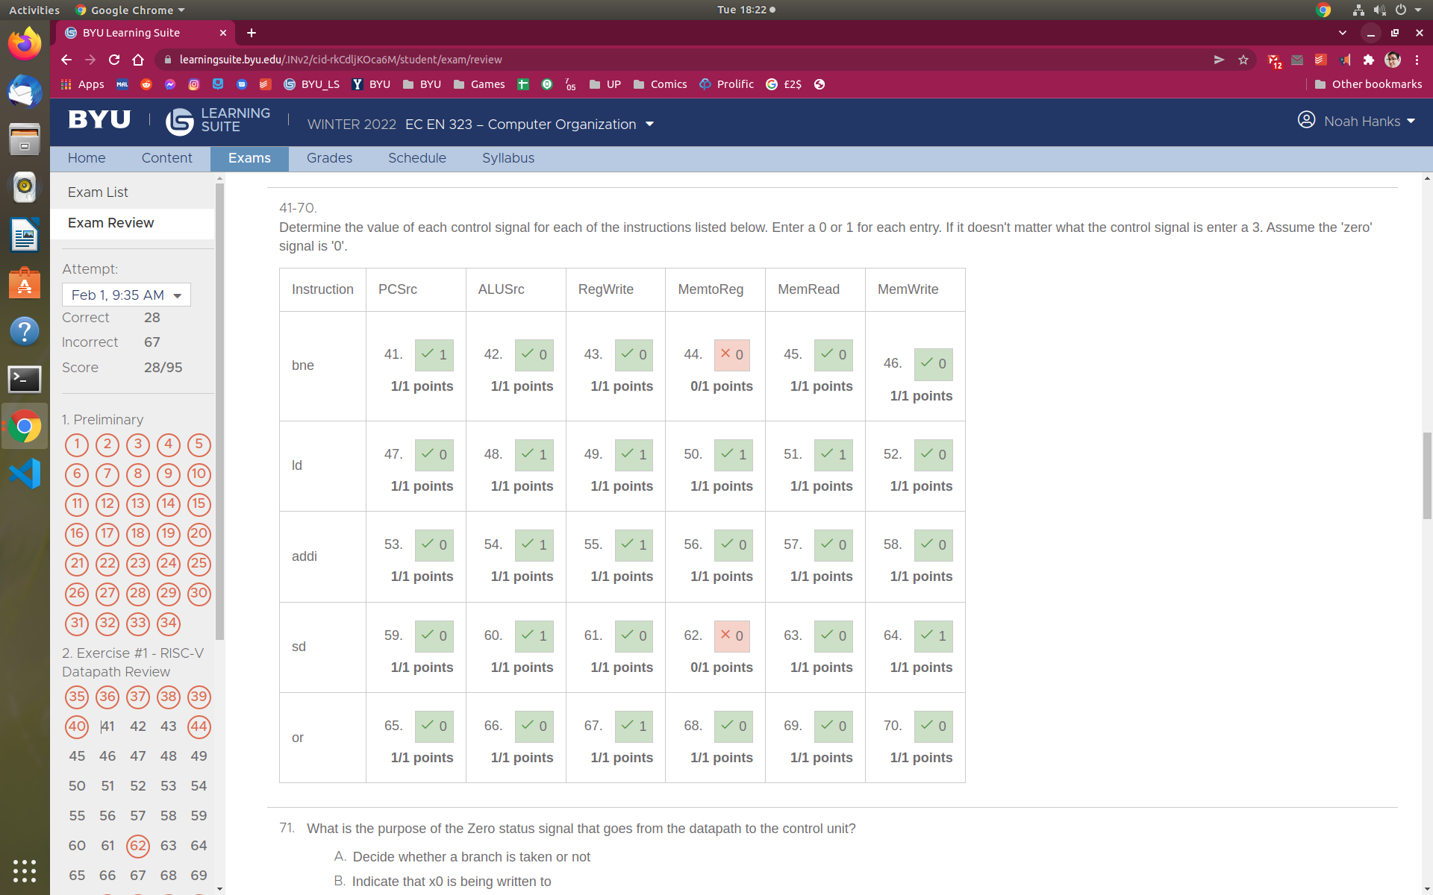

**01234567**

**Fffffca5**

**683**

**48**

**107**

**201**

**1**